UOW Summer Master Class news

Information received from the coordinator of The UOW Summer Master Classes Team, Gemma:

Applications for UOW Summer Master Classes closed just before the school holidays on Sunday 25th September. We received some great applications from Edmund Rice College - we really appreciate your efforts in promoting the program with your students!

As mentioned on the phone earlier today, students have been sent their application outcome by email and advised to let us know if they intend to accept the offer by Sunday 23rd October. 16 students who will transition to Year 12 this term received an offer.

Applications were assessed against academic results and the listed aspirations of each student to ensure the best fit for applicants.

Students who accept their place will be required to attend an on-campus Orientation Day at UOW Wollongong on the 13th or 14th December (dependent on the subject).

We will update you once acceptances close to notify you which students have accepted and will be taking part in the program.

For further information, phone (02) 4221 3450

To recap:

With nine subjects to choose from, the Summer Master Class program is your chance to:

- Prepare for your HSC
- Get a taste of university life attending while attending classes on campus
- Earn 6 credit points towards your UOW degree
- Secure a guaranteed admissions interview or offer for UOW

4 students completed Summer Master Class this year. In this newsletter I would like to showcase the achievements of 4 Year 12 students who excelled at summer master class in January this year:

Mr Gough presented the certificates to the following students:

High Distinction. This is the highest award a university student can achieve.

Riley Caldwell - Arts History
Mark Souffy - Visual Arts
Kane Davidson - Medicine

Distinction
George Delaveris - Visual Arts

Excellent achievements!

Interview questions:

Have you secured an interview for an apprenticeship? Most interviews are different, however, some possible ideas can be found below.

The interviewer may say:

Hello. My name is Mr/Mrs…………. Thank you for attending this interview. Shake your hand. Please be seated. Welcome to the interview.

Before the interview, consider:
- Punctuality
- Grooming
- Greeting
- Eye contact
- Handshake
- Posture
- Answering questions in sentence form

Possible questions:

- Why did you apply for this job?
- What do you know about what a person does in this occupation?
- What is your biggest achievement that you are proud of at the College?
- Tell me about your hobbies and interests.
- Give evidence of how you have practiced safety at school.
- What qualities do you have that what make you the preferred candidate?
- What is your favourite subject and why?
- What is your least favourite subject and why?
- How can you show evidence that you work well within a team?
- What evidence do you have that you will be a reliable employee? (punctual, reliable, honest, trustworthy)
- Not everyone is perfect, so what do you think would be your challenges at this job.
- Do you have any question?

The interviewer will say. This interview is now finished. I wish you all the best. Shake your hand and say good bye.

Interview dos and don'ts

- Do your homework. ...
- Make a good first impression. ...
- Listen and respond accordingly. ...
- Prepare smart, open ended questions to ask the interviewer. ...
- Sell your strengths and expertise. ...
- Don't speak poorly about your present or former employers. ...
- Don't falsify information. ...
- Don't speak over the interviewer.
- Don't be late. Arrive 15 minutes early to allow time for possible delay and use the extra time to freshen up for the interview if you have arrived early.
- Don't be pushy about salary. Don't place a large emphasis on salary. ...
- Don't talk too much. ...
- Don't exaggerate. ...
- Don't over or underdress

- 1: Sincerely thank your interviewers for their time.
- 2: Ask a question, even if you don't have one.
- 3: Practice your handshake.
- 4: Confirm your interest in the position.
- 5: Restate why you're the perfect candidate.
- Ask about short-term goals of the position.

ATAR information

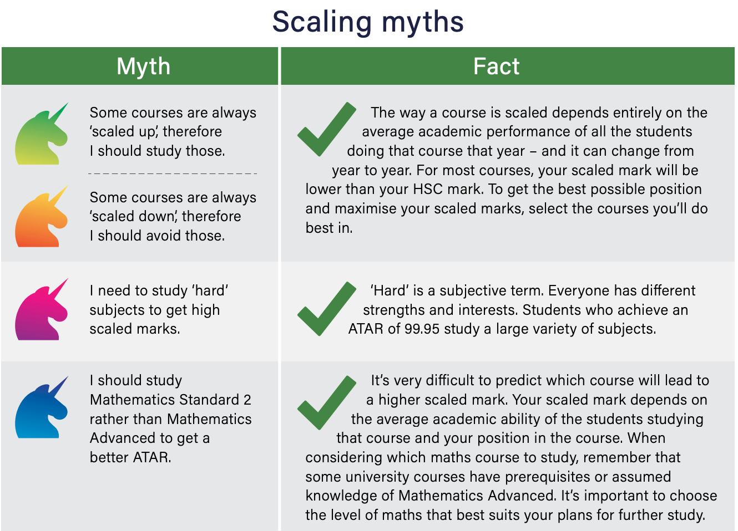

Not having an ATAR does not mean a poor HSC result. You could be placed first in 2 VET subjects and not qualify for an ATAR but still have an excellent HSC result.
Again I would like to stress that the ATAR is only used for University entry, not TAFE.

UOW Scholarships

https://www.uow.edu.au/study/scholarships/domestic/
https://scholarships.uow.edu.au/scholarships/search

Do you need help financially? Have you done well academically? Maybe you are an elite athlete? Whatever your situation, a scholarship can help you succeed at university. Studying can be expensive. They have a wide range of scholarships available to you which can assist with living costs, text books or that can contribute towards your fees.

UAC News

News from other institutions

Read the latest news from our institutions.
- Australian Catholic University
- CQUniversity
- International College of Management, Sydney
- Macquarie University
- University of Canberra
- University of Newcastle
- The University of Notre Dame
- University of Sydney
- University of Technology Sydney
- University of Wollongong
- UNSW Sydney
- Western Sydney University

Key dates
30 Sep 2022 11.59pm
Early bird application fee ends: application fee increases from $73 to $200
11 Nov 2022 7.30am
First SRS offers released. These are the first offers Year 12 students can receive through UAC
22 Nov 2022 11.59pm
Deadline to submit EAS application and documents to be considered for December Round 2
15 Dec 2022 6.00am
NSW HSC results released by NESA
15 Dec 2022 9.00am
NSW and ACT ATARs released
15 Dec 2022 9.00am
EAS eligibility letters release commences
22 Dec 2022 7.30am
December Round 2 offers released: first offers based on ATARs
23 Dec 2022 9.00am
Year 12 ES offers commence
12 Jan 2023 7.30am
January Round 1 offers released

NAVY news

Have you considered a career in the Navy?

Information on priority roles, fast-track opportunities, career pathways, benefits and upcoming events may be found at navyjobs@dfr.com.au.

Navy will consider your career goals, educational background, and individual requirements and see what opportunities there are for you, and take your experience into consideration to see how this may help with your application.

TAFE News
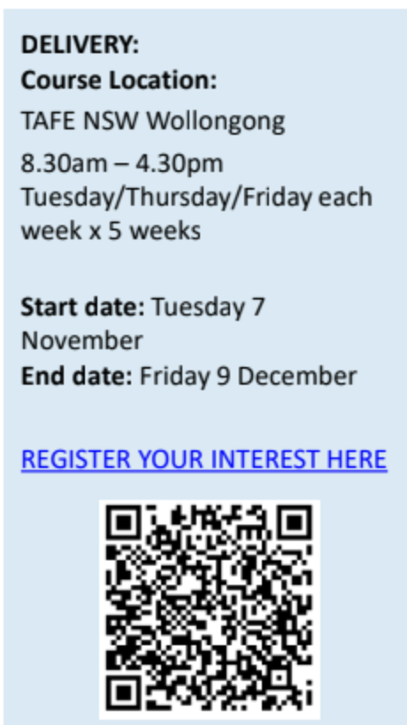
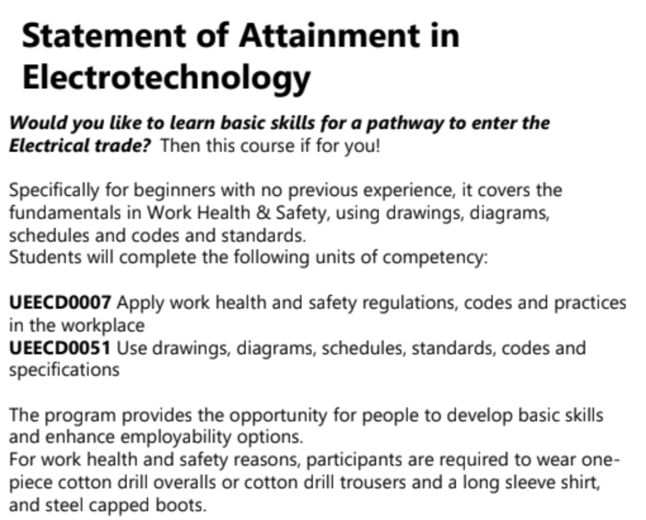

AIE News

From the Sydney Campus of Academy of Interactive Entertainment (AIE).

AIE is a world leader in games, film and visual effects education. We are your student's pathway into games, film, 3D and VFX. We offer introductory short courses and Diploma/Adv. Diploma career courses for those looking to work within the fields of game development, filmmaking, animation, simulation and 3D design.

We would love to further speak to you and your students on the potential of studying at the Academy! Whether that be in relation to our short courses or a future career course. If this sounds like something your students would be interested in, check out the Workshop form page for more information: https://aie.edu.au/school-workshops/

